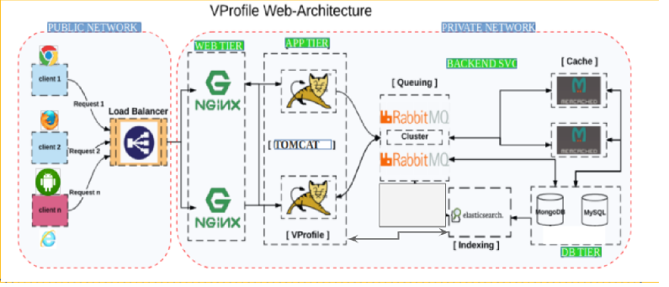

- Nginx
- Tomcat
- RabbitMq
- Memcahce
- DB

